Ch 31 Programming - RSA
CS3000
Rebekah Jensen

**If I need to submit more of the files that were created/provided by Dr. B, please let me know and I will resubmit

#program 1: generate keys
The instructions provided for this assignment made it easier to understand. I took my code for mod_exp, pseudoprime, euclid, and extended_euclid from a recent assignment (I believe Ch 31 RSA Uses) as I was prompted by the instructions. Although I’ve learned that these aren’t always necessary to complete an RSA project like this, they’re the more “sophisticated” way to go.

#program 2: usePublicKey
#program 3: usePrivateKey
I put all of this into one file to make it easier to keep track of. Not too difficult, both functions were pretty similar to each other. For some reason, I did have a hard time ensuring I was implementing the correct files that Dr. B gave us, but I think it worked out in the end. I added a bunch of print statements for fun to see what my code was up to.

It worked because my files have been encrypted now and can be decrypted. Cool stuff.

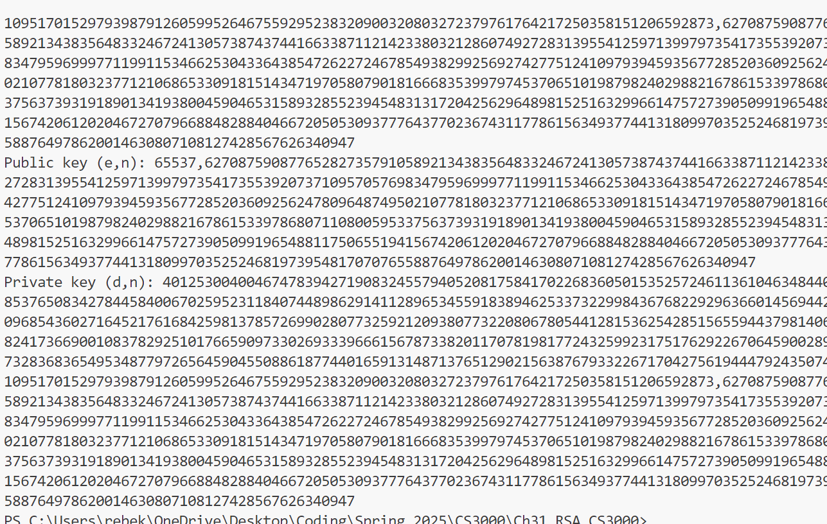
Random print statements in my terminal:

